# **IST769 Homework Submission**

Name: **Sathish Kumar Rajendiran**   
SUID: **666555028**  
Email: srajendi@syr.edu  
Due Date: **08/17/2021**

Task: **Hive and Pig**

Homework #:**6**

**Exercise(s):**

1. Load the comma-delimited HDFS dataset at clickstream/iplookup into a relation with an explicit schema. Use filter logic to remove the first row (which contains a header) then sort the output by IP and dump a comma-delimited data set to clickstream/iplookup_noheader. Record all your Pig commands required to complete your transformation.

**Solution:**

--list available folders

**fs -ls clickstream/iplookup**

--view the contents of the file

**fs -cat clickstream/iplookup/ip_lookup.csv**

--Load the file using PigStorage with explicit schema

**iplookup_File = LOAD ‘clickstream/iplookup/ip_lookup.csv’ USING PigStorage(‘,’) AS (ip:chararray,country:chararray,state:chararray,city:chararray,lat:double,lan:double);**

--Remove the header row from the file

**iplookup_File_Noheader = FILTER iplookup_File by ip! =’IP’;**

--Sort the file

**iplookup_File_Noheader_sorted = ORDER iplookup_File_Noheader by ip ASC;**

--Store the file into HDFS

**STORE iplookup_File_Noheader_sorted into ‘/user/cloudera/clickstream/iplookup_noheader’ USING PigStorage(‘,’);**

--view the contents of the file

**fs -cat clickstream/iplookup_noheader/part-r-00000**

**Evidence:**

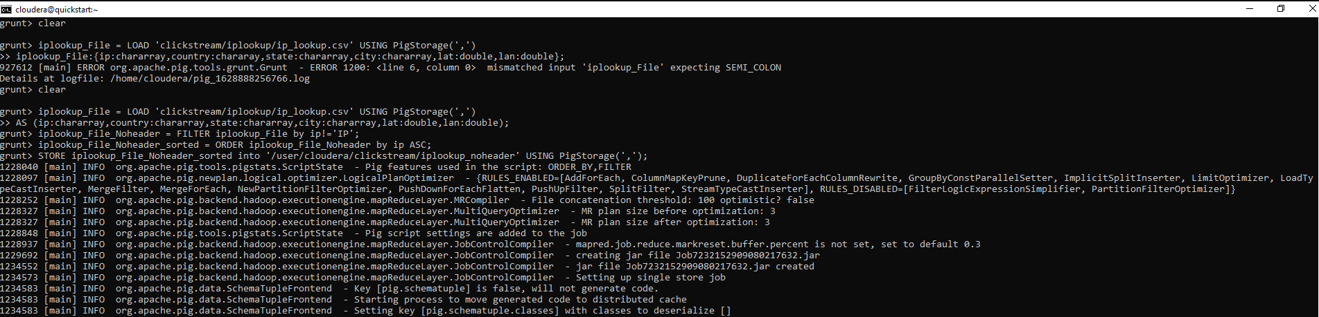

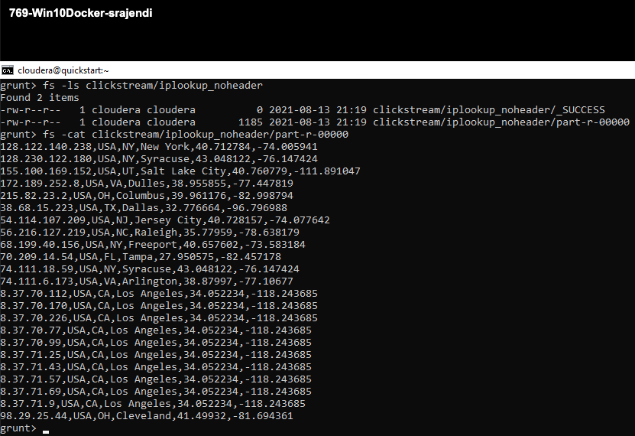

1. Write Pig commands to produce a count of IP Addresses by state codes, sorted by the count with highest values first, like this:  
   (CA, 10)  
   (NY, 4)  
   (VA, 2)  
   Etc.…  
   Record all your Pig commands required to complete your transformation.

**Solution:**

--Group by State

**iplookup_by_state = GROUP iplookup_File_Noheader_sorted by state;**

--view the schema

**describe iplookup_by_state;**

--count number of ip’s by state

**iplookup_by_state_n_counts = FOREACH iplookup_by_state GENERATE group as state, COUNT(iplookup_File_Noheader_sorted.ip) as counts;**

--sort number of ip’s by state

**iplookup_by_state_n_counts_sorted = ORDER iplookup_by_state_n_counts DESC;**

--view the output

**DUMP iplookup_by_state_n_counts_sorted;**

**Evidence:**

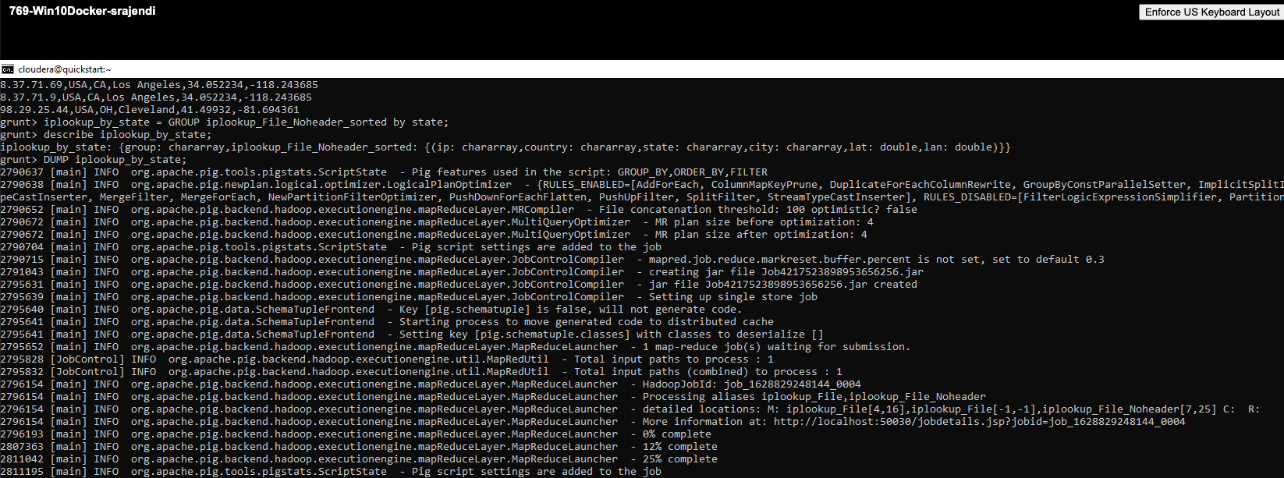

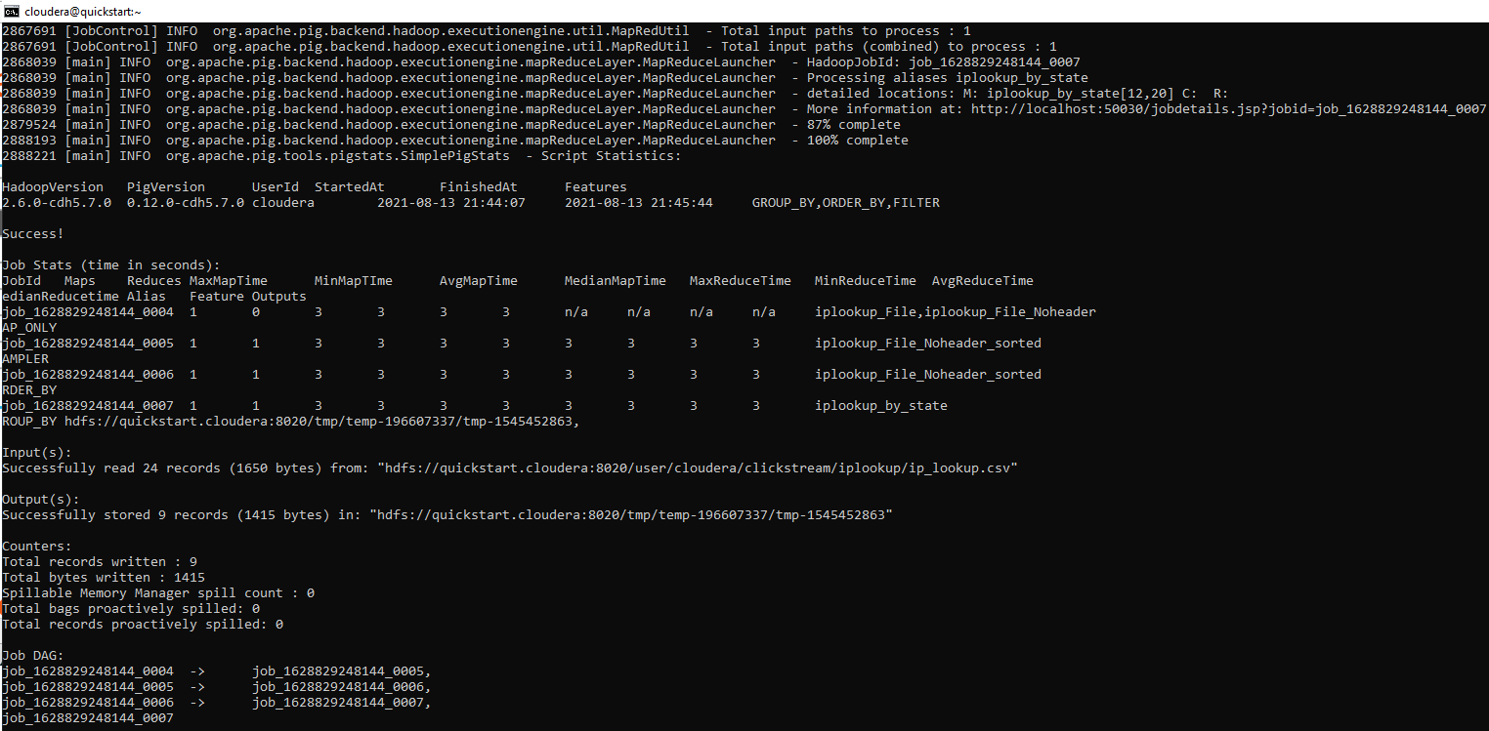

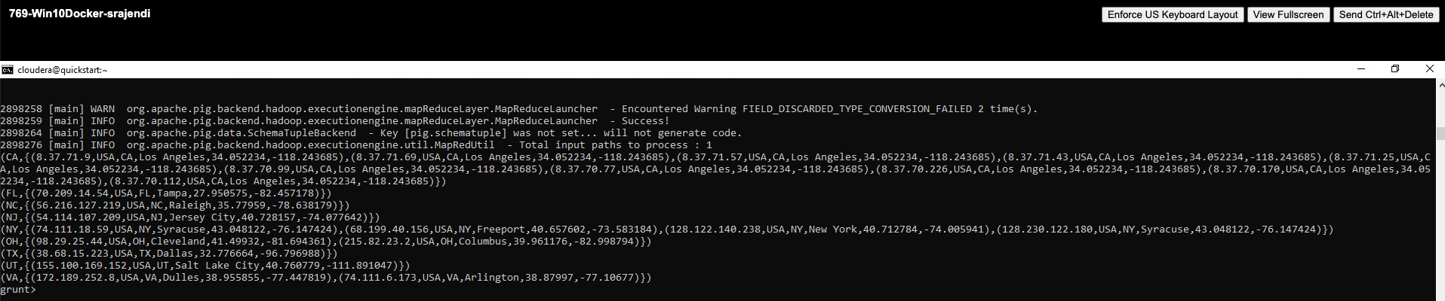

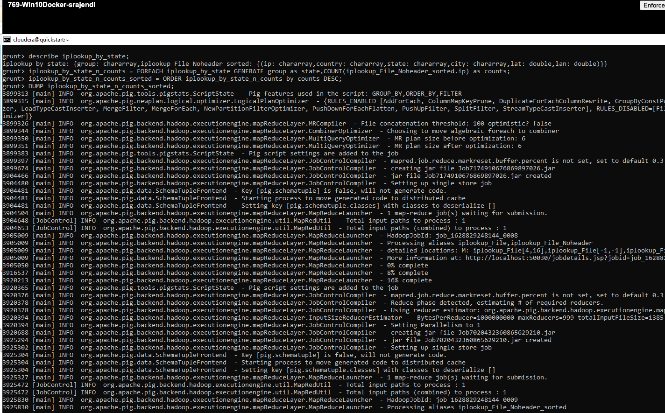

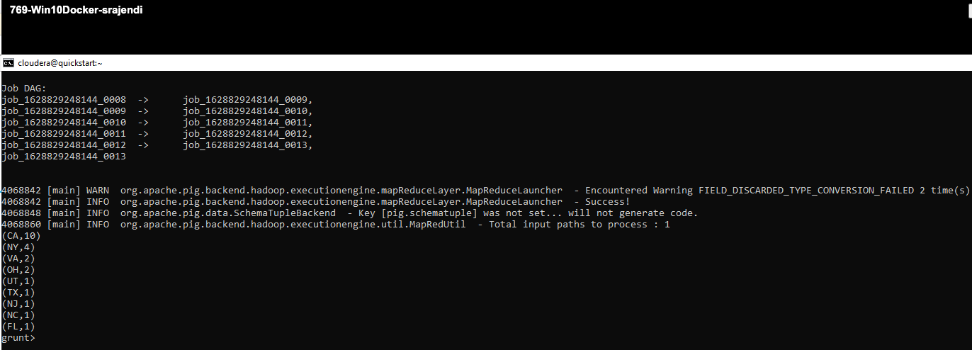

1. Use pig to load the web log files from **clickstream/logs** using the following schema:   
   reqdate:chararray, reqtime:chararray, x1:int, method:chararray, uri:chararray, x2:int ,x3:int, x4:int ,ipaddress:chararray, useragent:chararray, filter any rows which begin with a “#” (these are header rows and should be removed, then writes out the reqdate, reqtime, method, uri, ipaddress and useragent columns to a tab-delimited data set in HDFS **clickstream/logs_noheader**. HINT: The data is space delimited.

**Solution:**

--view the log files

**fs -ls clickstream/logs**

--view the content of log file

**fs -cat clickstream/logs/u_ex160211.log**

--LOAD the content of log files

**clickstream_logs = LOAD ‘clickstream/logs/*’ USING PigStorage(‘ ‘) AS (reqdate:chararray,reqtime:chararray,X1:int,method:chararray,uri:chararray,X2:int,X3:int,X4:int,ipaddress:chararray,useragent:chararray);**

--remove the header rows with “#”

**clickstream_logs_clean = FILTER clickstream_logs by reqdate! =’#’;**

--prepare the final file

**clickstream_logs_final = FOREACH clickstream_logs_clean GENERATE reqdate, reqtime, method, uri, ipaddress, useragent;**

--store the file into HDFS

**STORE clickstream_logs_final INTO ‘/user/cloudera/clickstream/logs_noheader’ USING PigStorage(‘\t’);**

--view the file created

**fs -cat clickstream/logs_noheader/part-m-00000**

**Evidence**:

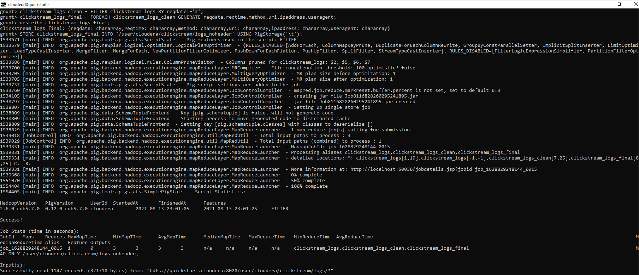

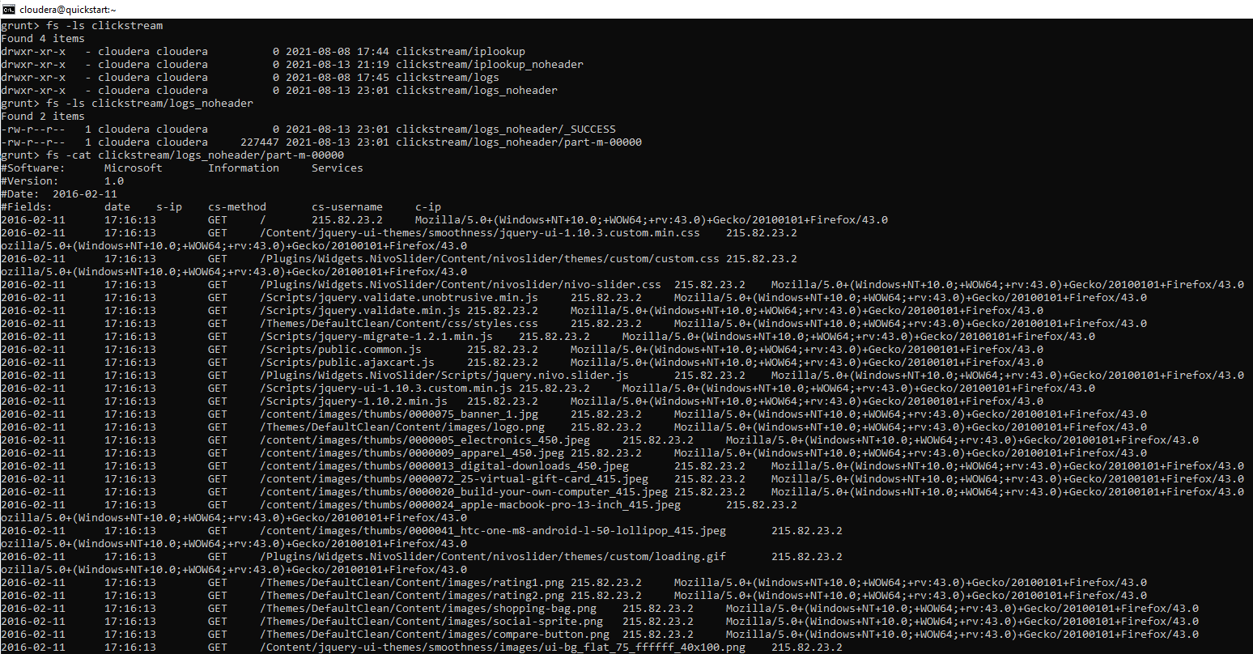

1. Use hive to create two external tables for the **clickstream/logs_noheader** and **clickstream/iplookup_noheader** files you created in the previous steps. These tables should be named **weblogs** and **iplookup** respectively and should be placed in the **clickstream** database. Be sure to record all HQL steps to complete the operations.

**Solution:**

--view the log files

**hdfs dfs -ls clickstream/*header**

--connect to Hive

**beeline -u jdbc:hive2://localhost:10000/default -u cloudera -p cloudera**

--create ‘clickstream’ database

**CREATE database clickstream;**

--view the log files on HDFS from Hive

**!sh hdfs dfs -ls clickstream/*header**

--create external table for ‘iplookup’

**create external table iplookup (ip string, country string, state string, city string, lat double, lan double) row format delimited fields terminated by ‘,’ location ‘/user/cloudera/clickstream/iplookup_noheader/’;**

--create external table for ‘weblogs’

**create external table weblogs (reqdate date, reqtime timestamp, method string, uri string, ipaddress string, useragent string) row format delimited fields terminated by ‘\t’ location ‘/user/cloudera/clickstream/logs_noheader/’;**

--view the hive tables schema

**describe iplookup;**

**describe weblogs;**

--view the data hive tables

**select * from iplookup limit 5;**

**select * from weblogs limit 5;**

**Evidence:**

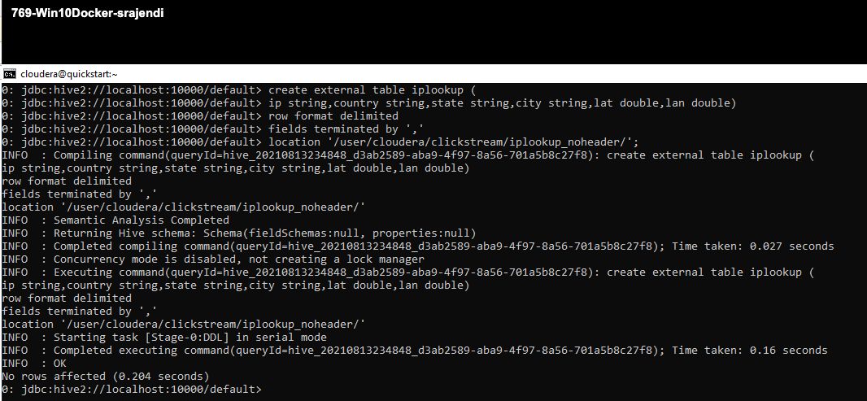

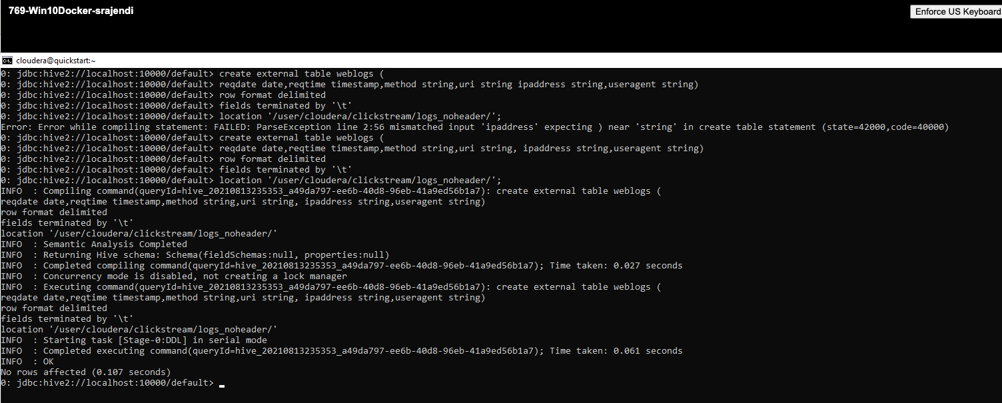

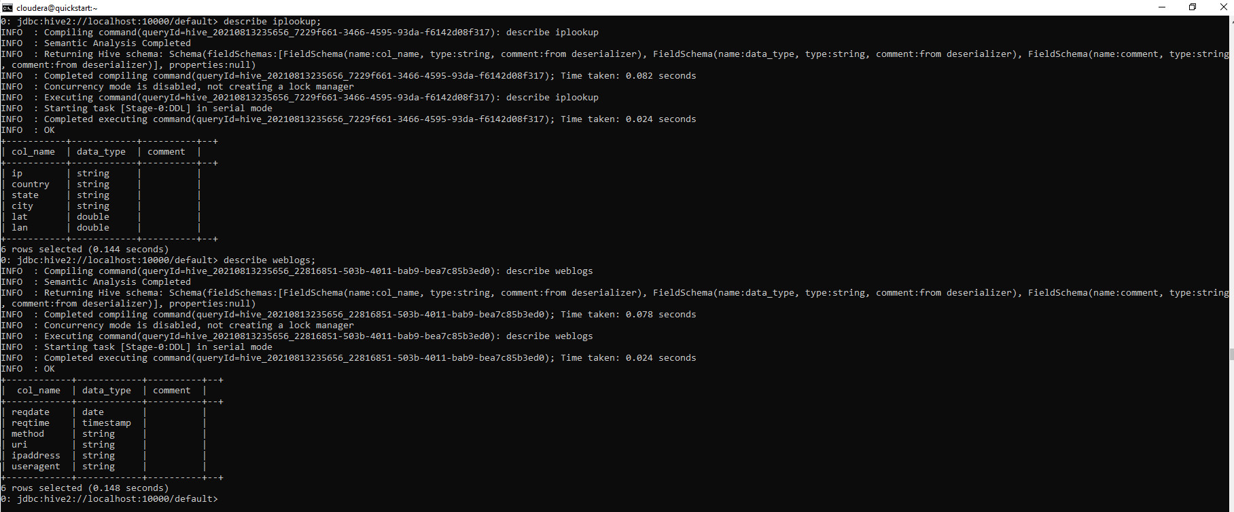

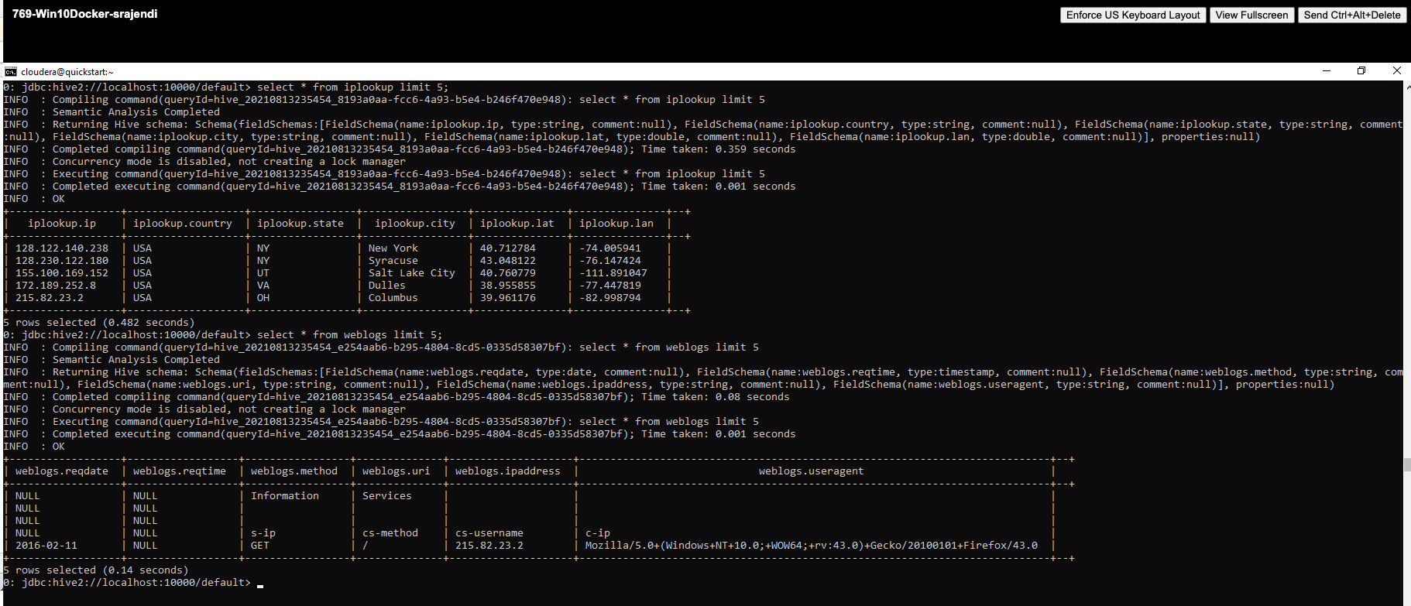

1. Write an HQL query to display the name of the city and the number of HTTP requests from that city (NOTE: each row in the web logs is an HTTP request). Order the output so cities with the most requests are at the top. If you complete the query correctly, you should see Syracuse has 272-page requests and Los Angeles has 24.

**Solution:**

--HQL to select cities with most ip requests

**select i.city, count(w.method) as http_requests**

**from iplookup as i join weblogs as w**

**on i.ip = w.ipaddress**

**group by i.city**

**order by http_requests desc;**

**Evidence:**

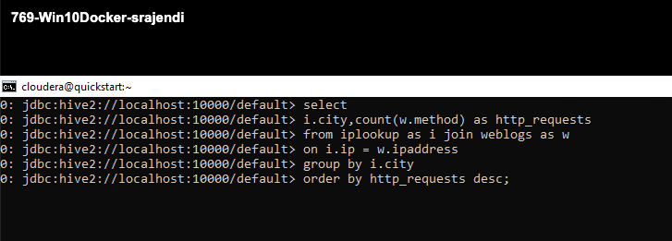

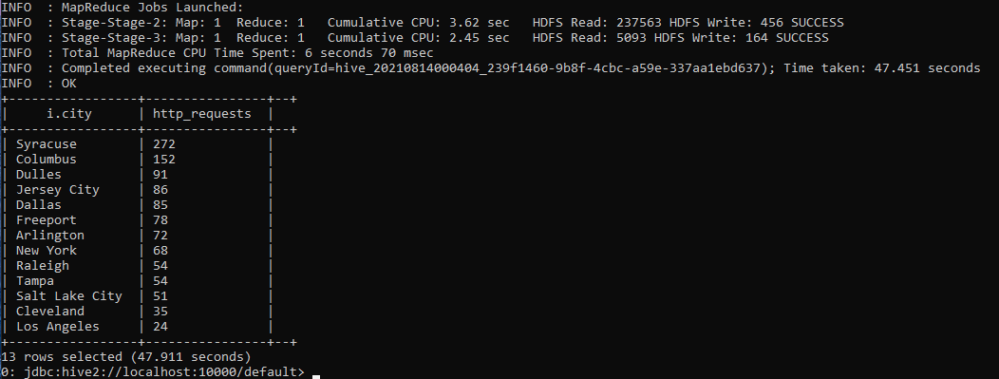

# **Appendix**

